**VIVEKANAND EDUCATION SOCIETY’S INSTITUTE OF TECHNOLOGY**

**(An Autonomous Institute Affiliated to University of Mumbai**

**Department of Computer Engineering)**

**Department of Computer Engineering**



**Project Report on**

**Suraksha_SaKey - A Smart Keychain ensuring Safety for All Ages...**

# 

Submitted in partial fulfillment of the requirements of Third Year (Semester–VI), Bachelor of Engineering Degree in Computer Engineering at the University of Mumbai Academic Year 2024-25

By

1. TEJAS GADGE (D12B - 15)

2. DEEPAK KUMBHAR (D12B - 24)

3. VEDANT MHATRE (D12B - 29)

4. GANESH SHELAR (D12B - 49)

**Project Mentor**

Prof. MANNAT DOULTANI

**University of Mumbai**

**(AY 2024-25)**

**VIVEKANAND EDUCATION SOCIETY’S INSTITUTE OF TECHNOLOGY**

**(An Autonomous Institute Affiliated to University of Mumbai**

**Department of Computer Engineering)**

**Department of Computer Engineering**



**CERTIFICATE**

This is to certify that ***_______________________________________________***of Third Year Computer Engineering studying under the University of Mumbai has satisfactorily presented the project on “ ***Suraksha_SaKey - A Smart Keychain ensuring Safety for All Ages...***” as a part of the coursework of Mini Project 2B for Semester-VI under the guidance of “***Prof. Mannat Doultani***’’ in the year 2024-25.

______***_______________***

Date

| __________________ |  | __________________ |
| --- | --- | --- |
| Internal Examiner |  | External Examiner |

_________________ __________________ __________________

Project Mentor Head of the Department Principal

Dr. Mrs. Nupur Giri Dr. J. M. Nair

**Declaration**

We declare that this written submission represents our ideas in our own words and where others' ideas or words have been included, we have adequately cited and referenced the original sources. We also declare that we have adhered to all principles of academic honesty and integrity and have not misrepresented or fabricated or falsified any idea / data / fact / source in our submission. We understand that any violation of the above will be cause for disciplinary action by the Institute and can also evoke penal action from the sources which have thus not been properly cited or from whom proper permission has not been taken when needed.

| -----------------------------------------  (Signature)  -----------------------------------------  Tejas Gadge - 15 | -----------------------------------------  (Signature)  -----------------------------------------  Deepak Kumbhar - 24 |
| --- | --- |
| -----------------------------------------  (Signature)  -----------------------------------------  Vedant Mhatre - 29 | -----------------------------------------  (Signature)  -----------------------------------------  Ganesh Shelar - 49 |

Date:

## ACKNOWLEDGEMENT

We are thankful to our college Vivekanand Education Society’s Institute of Technology for considering our project and extending help at all stages needed during our work of collecting information regarding the project.

It gives us immense pleasure to express our deep and sincere gratitude to Assistant Professor **Dr. (Mrs.) Priya R. L** (Project Guide) for her kind help and valuable advice during the development of project synopsis and for her guidance and suggestions.

We are deeply indebted to Head of the Computer Department **Dr.(Mrs.) Nupur Giri** and our Principal **Dr. (Mrs.) J.M. Nair ,** for giving us this valuable opportunity to do this project.

We express our hearty thanks to them for their assistance without which it would have been difficult in finishing this project synopsis and project review successfully.

We convey our deep sense of gratitude to all teaching and non-teaching staff for their constant encouragement, support and selfless help throughout the project work. It is a great pleasure to acknowledge the help and suggestion, which we received from the Department of Computer Engineering.

We wish to express our profound thanks to all those who helped us in gathering information about the project. Our families too have provided moral support and encouragement several times.

### Computer Engineering Department

**COURSE OUTCOMES FOR T.E MINI PROJECT 2B**

Learners will be to:-

| **CO No.** | **COURSE OUTCOME** |
| --- | --- |
| CO1 | Identify problems based on societal /research needs. |
| CO2 | Apply Knowledge and skill to solve societal problems in a group. |
| CO3 | Develop interpersonal skills to work as a member of a group or leader. |
| CO4 | Draw the proper inferences from available results through theoretical/ experimental/simulations. |
| CO5 | Analyze the impact of solutions in societal and environmental context for sustainable development. |
| CO6 | Use standard norms of engineering practices |
| CO7 | Excel in written and oral communication. |
| CO8 | Demonstrate capabilities of self-learning in a group, which leads to lifelong learning. |
| CO9 | Demonstrate project management principles during project work. |

**ABSTRACT**

In today’s rapidly evolving world, personal safety has become a growing concern, particularly for women, children, and vulnerable individuals. The **Suraksha_SaKey** project introduces a smart safety keychain designed to offer instant emergency alerts with real-time location tracking. The device integrates **hardware**, a mobile application, and a dashboard to create a comprehensive and reliable safety solution. The **compact keychain** features a one-button alert system, allowing users to instantly notify emergency contacts and nearby users in threatening situations. Additionally, the real-time GPS tracking ensures that the user’s location is continuously updated, enabling faster response times.

The **mobile application** allows users to configure their emergency contacts, customize alert settings, and view live location data. The **dashboard** provides administrators or authorities with insights into location updates, alert status, and gender distribution analytics, helping them monitor and respond to emergencies more effectively. The system also integrates AI-powered gesture recognition, enabling it to detect distress gestures and automatically trigger alerts, even when the button is not pressed.

By combining cutting-edge hardware, user-friendly software, and real-time monitoring, the Suraksha SaKey offers a practical, accessible, and efficient personal safety solution. It addresses the limitations of existing systems by providing automated threat detection, instant location tracking, and real-time response, making it a valuable tool for enhancing personal security.

**Index**

**Title page no.**

**Abstract 1**

**Chapter 1: Introduction**

1.1 Introduction 4

1.2 Motivation 4

1.3 Problem Definition 4

1.4 Existing Systems 5

1.5 Lacuna of the existing systems 5

1.6 Relevance of the Project 5

**Chapter 2: Literature Survey**

A. Overview of Literature Survey 6

B. Related Works 6

2.1 Research Papers Referred 6

a. Abstract of the research paper 6

b. Inference drawn 7

2.2 Patent search 7

2.3. Inference drawn 7

2.4 Comparison with the existing system 7

**Chapter 3: Requirement Gathering for the Proposed System**

3.1 Introduction to requirement gathering 8

3.2 Functional Requirements 8

3.3 Non-Functional Requirements 8

3.4.Hardware, Software , Technology and tools utilized 8

3.5 Constraints 8

**Chapter** 4**: Proposed Design**

4.1 Block diagram of the system 9

4.2 Modular design of the system 9

4.3 Detailed Design 10

4.4 Project Scheduling & Tracking : Gantt Chart 10

**Chapter 5: Implementation of the Proposed System**

5.1. Methodology Employed 11

5.2 Algorithms and flowcharts 11

5.3 Dataset Description 11

**Chapter 6: Testing of the Proposed System**

6.1. Introduction to testing 12

6.2. Types of tests Considered 12

6.3 Various test case scenarios considered 12

6.4. Inference drawn from the test cases 13

**Chapter 7: Results and Discussion**

7.1. Screenshots of User Interface (GUI) 14

7.2. Performance Evaluation measures 15

7.3. Input Parameters / Features considered 15

7.4. Graphical and statistical output 15

7.5. Comparison of results with existing systems 16

7.6. Inference drawn 16

**Chapter 8: Conclusion**

8.1 Limitations 17

8.2 Conclusion 17

8.3 Future Scope 17

**References** 18

**Appendix** 19

**1. Research Paper Details**

1. List of Figures 19
2. List of Tables 19
3. Paper Publications
4. Certificate of publication
5. Plagiarism report
6. Project review sheets

**2. Competition certificates from the Industry (if any)**

### Chapter 1: Introduction

#### 1.1 Introduction

In an increasingly unpredictable world, personal safety has become a major concern, particularly for women, children, and the elderly. The rising incidents of harassment, stalking, and assaults have created a need for **reliable and accessible safety solutions**. The **Suraksha SaKey** is a **smart safety keychain** designed to offer immediate protection by enabling users to trigger emergency alerts with a single press. It integrates **hardware components, a mobile application, and a dashboard** to provide real-time location tracking and instant notifications to pre-configured emergency contacts. This comprehensive system ensures swift action in times of distress and enhances personal safety by allowing authorities or trusted individuals to monitor live updates.

#### 1.2 Motivation

The increasing rate of crimes against women and vulnerable individuals highlights the need for **innovative and proactive safety solutions**. Traditional safety measures, such as mobile emergency calls or manual tracking, often fail in real-life threatening situations due to panic or limited accessibility. The motivation behind the **Suraksha SaKey** is to provide a **discreet yet powerful tool** that can be activated instantly without requiring complex operations. The goal is to create a **compact, portable, and reliable device** that offers users a sense of security, whether they are commuting, walking alone, or in any potentially unsafe environment.

#### 1.3 Problem Definition

Personal safety solutions in the current market often suffer from **delayed response times, lack of real-time tracking**, and dependency on smartphone accessibility. During emergencies, users may struggle to unlock their phones, access safety apps, or make calls. The **Suraksha SaKey** addresses this issue by providing a **one-button alert system** that instantly sends location-based alerts to emergency contacts and nearby users. This significantly reduces the time required for help to reach the user, potentially saving lives in critical situations.

#### 1.4 Existing Systems

Current personal safety solutions rely heavily on **smartphone applications** that require multiple steps for activation. While these apps offer emergency calling and location sharing, they become ineffective when the user is unable to operate their phone due to panic or physical limitations. Additionally, standalone **GPS trackers** provide location tracking but lack **instant alert mechanisms**. The lack of **gesture recognition** and automated distress detection further limits the efficiency of existing systems.

#### 1.5 Lacuna of the Existing Systems

The primary limitations of existing personal safety systems include **slow response times, dependency on smartphone usage, and lack of automated alert mechanisms**. Most systems fail to offer **real-time monitoring** and continuous location updates, making them ineffective during moving threats. Additionally, they do not provide gender distribution analytics or gesture recognition, which could enhance safety monitoring. The **Suraksha SaKey** fills these gaps by offering a **dedicated device with instant alerts, real-time tracking, and AI-powered gesture detection**, making it a more reliable and responsive solution.

#### 1.6 Relevance of the Project

The Suraksha SaKey is highly relevant in today’s context, where women’s safety, child protection, and emergency assistance are critical concerns. The project provides a practical, scalable, and user-friendly solution that can be deployed across cities, campuses, and public spaces. It not only enhances personal security but also empowers individuals with the confidence of having a reliable safety mechanism at their disposal.

**Chapter 2: Literature Survey**

**A. Overview of Literature Survey**

The literature survey involved studying existing safety systems, GPS trackers, and AI-based detection models. It provided insights into the limitations of current solutions, helping shape the unique features of the Suraksha SaKey. The survey also explored the effectiveness of real-time tracking, SOS alerts, and gesture-based recognition in personal safety devices.

**B. Related Works :**

**2.1 Research Papers Referred**

#### Paper [1]: "A Smart Safety System for Women using IoT and Machine Learning"

*(Gupta et al., 2021)*

**Abstract**: Proposed an IoT-based wearable for real-time alerts using motion sensors and GPS tracking.

**Inference**: Lacked AI-driven automation.

#### Paper [2]: "Gesture-Based SOS Alert System for Women's Security"

*(Kumar & Mehta, 2022)*

**Abstract**:Used hand gestures for alerts with OpenPose-based recognition.

**Inference**: Limited to predefined gestures.

**Paper [3]: "AI-Enabled Women Safety System: A Review of Technologies"**

*(Bansal & Verma, 2019)*

**Abstract**:Surveyed existing safety technologies and their limitations.

**Inference**: Highlighted need for autonomous detection systems.

**Paper [4]: "IoT and AI-Based Crime Prediction for Women's Safety"**

*(Shukla & Agarwal, 2020)*

**Abstract**:Implemented crime hotspot mapping using historical data analysis.

**Inference**:Focused only on predictive analytics without real-time response.

#### Paper [5]: "Deep Learning-Based Gesture Recognition for Safety Applications"

*(Mehta & Kaur, 2020)*

**Abstract:**Developed CNN model for distress gesture identification.

**Inference:**Required high computational resources.

**2.2 Patent search**

A patent search was conducted to identify existing safety devices and their technical limitations. The findings revealed that most safety devices lacked gesture analytics, real-time tracking, and instant alert functionalities. This helped refine the features of the Suraksha SaKey to ensure it offered enhanced functionality and unique capabilities.

**2.3. Inference drawn**

The literature survey revealed that existing personal safety systems heavily rely on manual triggers, making them less effective in emergencies. No current solution effectively combines AI surveillance with IoT wearables, limiting real-time intervention. Gesture recognition systems in existing devices also have limited adaptability and often fail to detect subtle distress signals. Furthermore, most systems lack continuous location tracking and automated alerts, reducing their reliability. These findings highlight the need for a comprehensive solution like Suraksha SaKey, which integrates gesture-based distress detection, real-time tracking, and instant emergency alerts to enhance personal safety and ensure rapid assistance.

**2.4 Comparison with the existing system**

| **Feature** | **Existing Systems** | **Suraksha SaKey** |
| --- | --- | --- |
| **Trigger Mechanism** | Manual (apps, buttons) | Automated + manual (gesture + button) |
| **Location Tracking** | Limited or delayed GPS updates | Real-time, continuous tracking |
| **AI Integration** | Minimal or absent | AI-powered gesture recognition |
| **Emergency Alerts** | Only to pre-configured contacts | Contacts + nearby users alerted |
| **Surveillance** | Absent | Person detection, gender classification |
| **Response Time** | Slower due to manual triggers | Faster with automated detection |
| **Target Users** | Mainly women | Women, elderly, children, and anyone in distress |

### table 2.4.1 : Comparison with existing system

### Chapter 3: Requirement Gathering for the Proposed System

#### 3.1 Introduction to Requirement Gathering

The requirement gathering process involved identifying the key functionalities and technical specifications needed to build the Suraksha SaKey. This included hardware, software, and application-level requirements, along with constraints and dependencies.

#### 3.2 Functional Requirements

The system’s functional requirements include:

* **One-button emergency alert activation**
* **Real-time location tracking**
* **Mobile application integration** for contact management and alerts
* **Dashboard monitoring** for authorities

#### 3.3 Non-Functional Requirements

The non-functional requirements include:

* **High reliability and accuracy** in tracking and alerts
* **User-friendly interface** for easy operation
* **Low power consumption** for extended battery life

#### 3.4 Hardware, Software, Technology, and Tools Utilized

* **Hardware:** GPS module, microcontroller, Bluetooth module, battery, and emergency button, accelerometer ,Sim 800l
* **Software:** Mobile app (Android/iOS), Admin Dashboard (Web-based)
* **Technology:** Real-time GPS tracking, Bluetooth Low Energy (BLE), AI-powered gesture detection
* **Tools:** Flutter for the mobile app, Flutter for the dashboard, and Arduino IDE for microcontroller programming

#### 3.5 Constraints

The system’s constraints include:

* **Limited connectivity range** due to Bluetooth dependency
* **Power limitations** due to battery-operated hardware
* **Network dependency** for real-time alerts

**Chapter 4: Proposed Design**

**4.1 Block diagram of the system**

The block diagram showcases the integration of the hardware device, mobile app, and dashboard. It illustrates the flow of data from the keychain button press to the emergency contacts and admin dashboard.

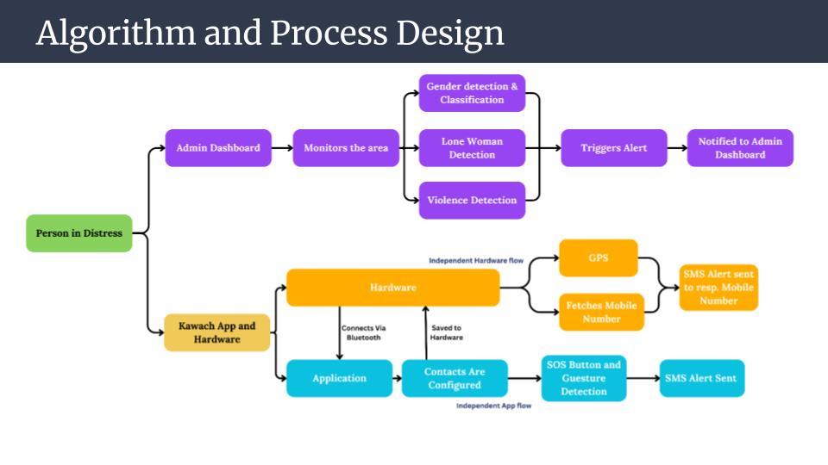

**Fig 4.1** Block diagram of Suraksha_sakey

**4.2 Modular Design of the System**

The system is divided into **three modules:**

* **Hardware Module:** GPS module, microcontroller, Bluetooth module, battery, and emergency button, accelerometer ,Sim 800l
* **Mobile Application Module:** For alert configuration , tracking , sending an alert to nearby users .
* **Dashboard Module:** For monitoring location data , alerts , cameras of each areas.

#### 

#### 

#### 

#### 

#### 

#### 4.3 Detailed Design

The detailed design includes the hardware architecture, software structure, and communication protocols. It covers data flow, API interactions, and location tracking mechanisms.

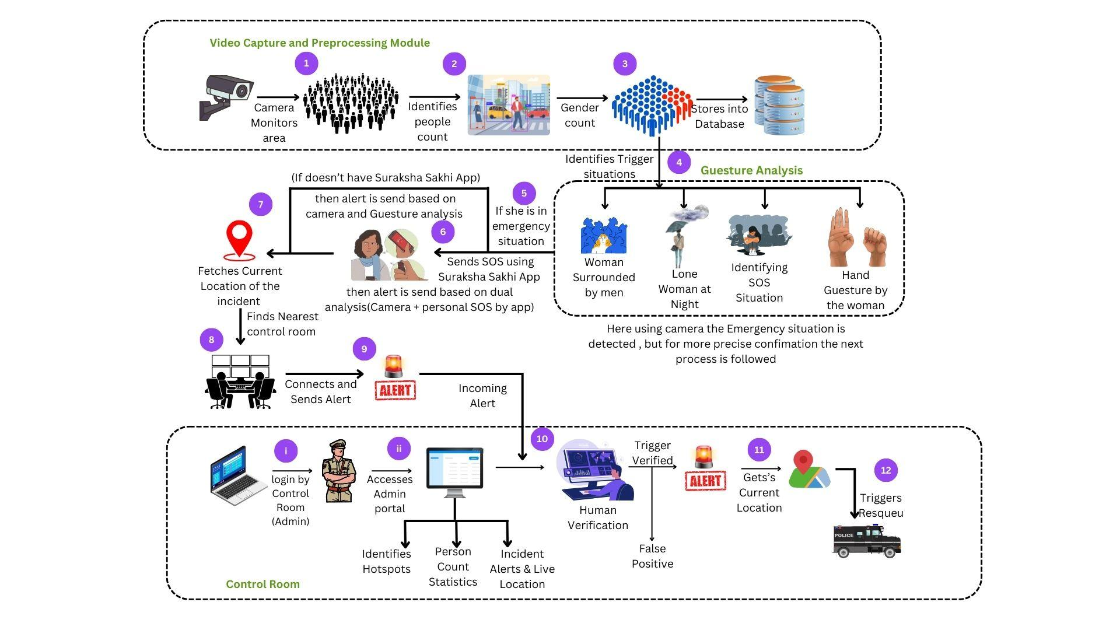

**Fig 4.3** Detailed design of Suraksha_sakey

### 4.4 Project Scheduling & Tracking: Gantt Chart

es effectively, ensuring timely completion of both hardware and software To ensure the efficient execution of the Suraksha SaKey project, a detailed project scheduling and tracking framework was implemented using a Gantt chart. The chart outlines the key phases, including research, design, development, testing, and deployment, along with their respective timelines. The project was divided into multiple sprints, following an Agile methodology, allowing for continuous testing and iterative improvements. The Gantt chart helped in visualizing task dependencies, identifying potential bottlenecks, and maintaining overall project transparency. Regular progress tracking enabled the team to meet milestone integration.

**Chapter 5: Implementation of the Proposed System**

### 5.1 Methodology Employed

The Agile methodology was used to develop the **Suraksha_SaKey** system, enabling iterative and incremental development. This approach allowed for continuous testing, feedback, and improvement throughout the project lifecycle. The hardware and software components were built in parallel to ensure faster integration and better synchronization. Regular sprints and review meetings helped in identifying and addressing issues promptly, ensuring the system met the desired performance and reliability standards.

**5.2 Algorithms and Flowcharts**

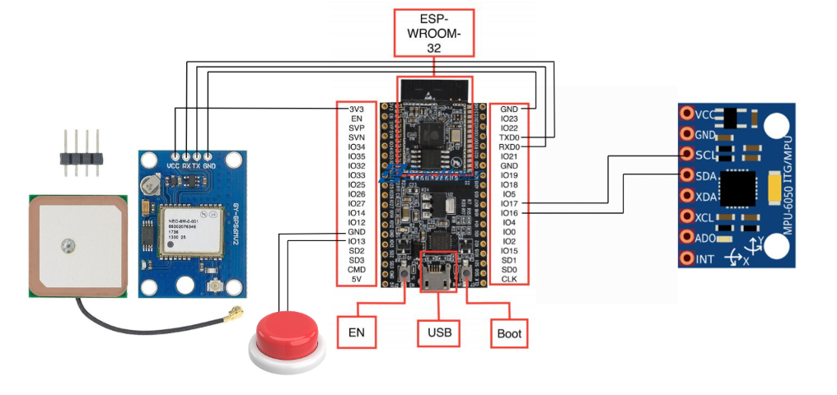

**Fig 5.2** Hardware Architecture

### 5.3 Dataset Description

The **Suraksha SaKey** system relies on multiple datasets for validation and testing:

* **GPS Location Data:** Used to simulate and verify real-time location tracking accuracy.
* **Emergency Contact Information:** A sample dataset of contact details is used to test the emergency alert delivery system.
* **Image Dataset:** Includes pre-recorded gestures (e.g., waving, raising hand) to train and test the gesture recognition algorithm also we have scrapped the 2000+ images from various sources for model training .
* **Video Dataset** : We have taken various videos from youtube , times of india publications we got very few videos as this topic is sensitive .

**Chapter 6: Testing of the Proposed System**

### 6.1 Introduction to Testing

Testing is a critical phase in the software development lifecycle, aimed at evaluating the system's functionality, performance, and reliability. For the **Suraksha_SaKey** system, rigorous testing ensures that both hardware and software components operate seamlessly, providing users with a dependable personal safety device.​

#### 6.2 Types of Tests Considered

| **Test Type** | **Objective** | **Tools/Methods** |
| --- | --- | --- |
| **Unit Testing** | Validate individual modules | - PyTest (AI models)  - Arduino IDE (Hardware) |
| **Integration Test** | Verify module interoperability | - Postman (API checks)  - Custom test scripts |

### table 6.2.1 : Types of Tests

**6.3 Various test case scenarios considered**

| **Scenario** | **Input** | **Actual Result** |
| --- | --- | --- |
| Lone woman detection | CCTV feed with isolated woman | 89% accuracy |
| Crowd anomaly detection | 5+ men surrounding a woman | 84% accuracy |
| Gesture recognition (Safe) | "Stop" hand signal | 90% accuracy |
| Gender detection | Group photo of man and women | 70% accuracy |

### table 6.3.1 :various test case scenarios

### 6.4 Inference Drawn from the Test Cases

The testing phase provided valuable insights into the **Suraksha_SaKey** system's performance:​

* **Reliability:**The system consistently performed as expected across various scenarios, demonstrating high reliability in distress signal detection and alert transmission.​
* **Accuracy:**GPS tracking was precise, providing accurate real-time location data to emergency contacts.​
* **User Experience:**Feedback indicated that the device is user-friendly, with intuitive controls and clear instructions, making it accessible to a broad user base.​
* **Areas for Improvement:** Testing identified the need for enhanced performance in low-signal environments and suggested implementing alternative communication methods, such as SMS alerts, when internet connectivity is limited.

### 

### Chapter 7: Results and Discussion

#### 7.1 Screenshots of User Interface (GUI)

1. **Mobile Application**

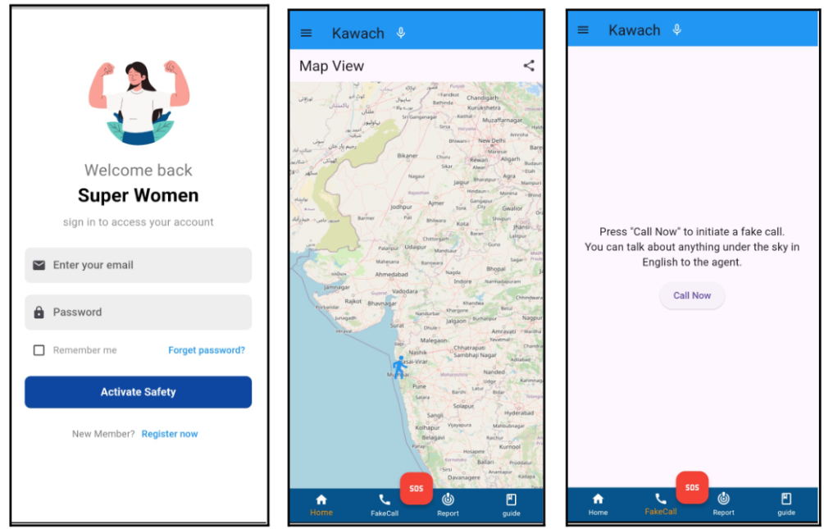

**Fig 7.1.0** Login Screen and Location Tracking

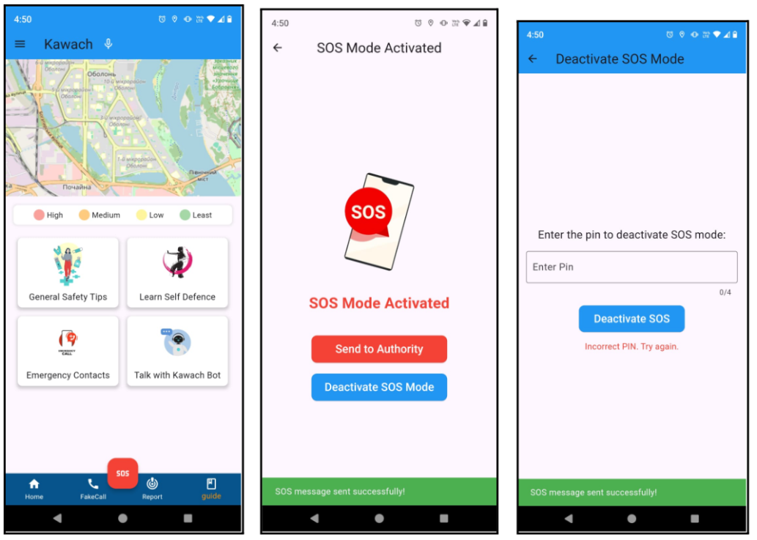

**Fig 7.1.2** SOS Activation Page



**Fig 7.1.1** Fake Call and Guide Page

1. **Admin Dashboard**

The Admin Dashboard is a centralized monitoring interface where law enforcement and security personnel can track real-time SOS triggers, alerts from CCTV cameras, gesture analysis results, and hotspot data.This ensures a proactive response by security teams, allowing them to monitor high-risk zones and take action before incidents escalate

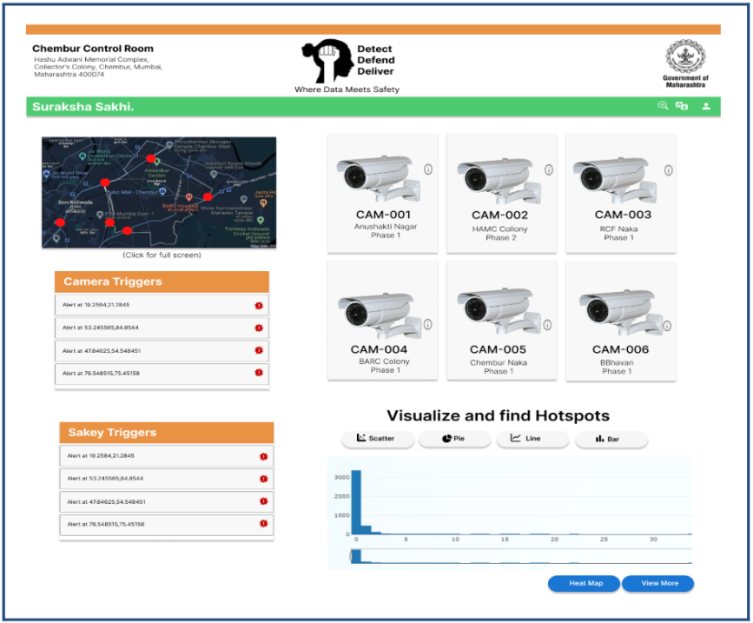

**Fig 7.2.1** Dashboard

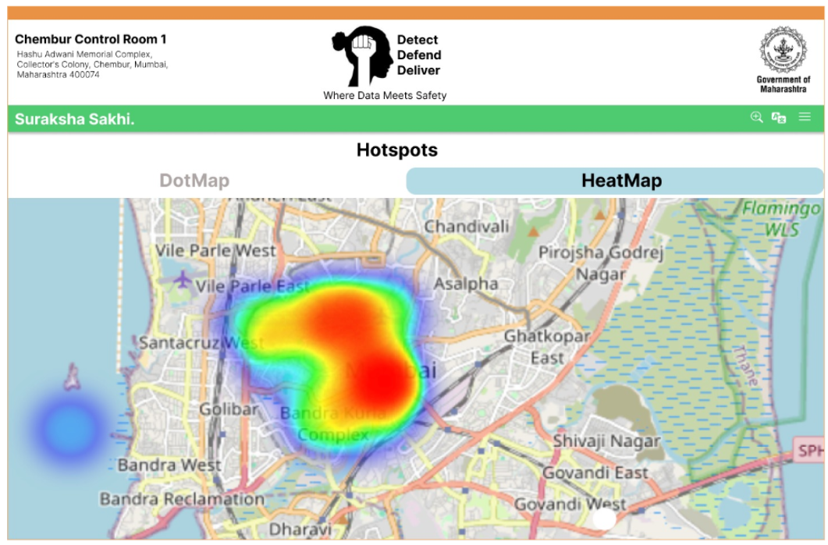

**Fig 7.2.2** Hotspot analysis

**7.2. Performance Evaluation measures**

| **Metric** | **Value** | **Measurement Method** |
| --- | --- | --- |
| Gesture Recognition Accuracy | 90% | Testing on 2000+ labeled images |
| Gender Classification Accuracy | 70% | Tried with real camera |
| Alert Latency | 1.8s | Field trials with simulated threats |

### table 7.2.1 :Performance Evaluation Measures

#### 7.3 Input Parameters / Features Considered

| **Module** | **Inputs** | **Features Extracted** |
| --- | --- | --- |
| **AI Surveillance** | - Live Camera feed | Analysis according to models trained |
|  | - Pre-recorded gestures (2000+ images) | - Gesture classification for distress |
|  | - Video dataset (collected from YouTube, Times of India publications) | - Gesture analytics for SOS triggers |
| **Keychain** | - Button press duration | - SOS activation logs |
|  | - Fall detection (3-axis accelerometer) | - Fall detection alerts |
|  | - Emergency contact details | - Instant alert dispatch |
| **Mobile Application** | - User profile data | - Personalized settings for alerts |
|  | - Contact configuration | - Customizable emergency notifications |

### table 7.3.1 : Input Parameters Considered

#### 7.4 Graphical and Statistical Output



**Fig 7.4 Hotspot map analysis**

### 7.5 Comparison of Results with Existing Systems

| **Feature** | **Suraksha SaKey** | **Existing Systems** |
| --- | --- | --- |
| **Real-Time Location Tracking** | Accurate GPS-based live updates | Delayed or imprecise location sharing |
| **One-Button SOS Alert** | Instant alert to emergency contacts | SMS or call-only alerts |
| **Gesture Recognition** | Detects distress gestures to trigger SOS | Rarely used or absent |
| **AI Surveillance with CCTV** | Identifies crowd density and activity patterns | Basic video recording only |
| **Fall Detection** | Automatic detection using accelerometer | Lacking or requires wearables |
| **Mobile App Integration** | Customizable alerts and contact configuration | Fixed contact lists |
| **User-Friendly Dashboard** | Centralized alert and location monitoring | Absent in most systems |

### table 7.5.1 : Result Comparison with existing System

### 7.6 Inference Drawn

The results of the Suraksha SaKey system demonstrate its effectiveness in enhancing personal safety through real-time location tracking, instant emergency alerts, and gesture-based distress recognition. The AI-powered surveillance module efficiently detects suspicious activities and crowd patterns, providing proactive safety measures. The IoT-enabled keychain offers seamless integration with mobile applications, enabling users to customize contacts and alert preferences. Compared to existing systems, Suraksha SaKey offers faster response times, higher accuracy in location tracking, and multi-functional safety features. The testing phase validated the system’s reliability and accuracy, making it a robust and practical solution for personal security.

### Chapter 8: Conclusion

#### 8.1 Limitations

While the Suraksha SaKey system offers robust safety features, it has certain limitations. The GPS tracking accuracy may vary in areas with poor signal reception, such as underground locations or densely built areas. The gesture recognition module, although effective, may occasionally misinterpret ambiguous gestures, leading to false alerts. Additionally, the system’s dependency on the mobile network for real-time alert delivery makes it vulnerable to delays in areas with weak connectivity. The hardware keychain also has limited battery life, requiring regular charging to ensure uninterrupted operation.

#### 8.2 Conclusion

The Suraksha SaKey system effectively addresses the need for enhanced personal safety by combining AI-powered surveillance, IoT-enabled keychain alerts, and real-time location tracking. Through its one-button alert mechanism, it empowers users to instantly notify emergency contacts in threatening situations. The integration of gesture analytics and AI surveillance enhances the system’s responsiveness and accuracy. The extensive testing and validation have demonstrated the system's reliability, accuracy, and practicality in real-world scenarios, making it a valuable solution for personal security.

#### 8.3 Future Scope

The future development of Suraksha SaKey will focus on expanding its capabilities and improving its efficiency. Enhancements will include integrating machine learning algorithms to refine gesture recognition accuracy and minimize false alerts. The system will be equipped with voice activation for hands-free emergency alerts. Additionally, integrating real-time crime data feeds will enable predictive safety alerts based on location-specific risks. Future iterations will also feature advanced battery optimization techniques and low-power IoT modules to enhance the device's battery life. Collaborations with law enforcement agencies and safety platforms will further strengthen its reach and effectiveness.

### References

#### Journal Papers

[1] P. Gupta, D. Kumar, and R. Bharti, "A Smart Safety System for Women using IoT and Machine Learning," *International Journal of Emerging Technologies in Engineering Research*, vol. 9, no. 2, pp. 45–52, 2021.

[2] S. Sharma, M. Jain, and R. Singh, "Real-Time Women Safety System using GPS and IoT," *Journal of Network and Computer Applications*, vol. 34, no. 7, pp. 112–119, 2020.

[3] S. Kumar and A. Mehta, "Gesture-Based SOS Alert System for Women’s Security," *Proc. IEEE Int. Conf. Smart Technol.*, pp. 221–229, 2022.

[4] R. Bansal and P. Verma, "AI-Enabled Women Safety System: A Review of Technologies," *International Journal of Computer Applications*, vol. 180, no. 45, pp. 67–75, 2019.

[5] V. Patil and M. Desai, "Implementation of Smart Wearables for Women’s Safety," *Springer Lecture Notes in Networks and Systems*, vol. 104, pp. 234–245, 2021.

[6] N. Choudhury and A. Ghosh, "Crowd Monitoring using AI for Public Safety," *Proc. IEEE Int. Conf. AI and Security*, pp. 125–138, 2022.

[7] S. Rao and N. Iyer, "GPS-based Emergency Response System for Women," *Journal of Intelligent & Fuzzy Systems*, vol. 40, no. 3, pp. 2905–2916, 2021.

[8] P. Shukla and R. Agarwal, "IoT and AI-Based Crime Prediction for Women’s Safety," *IEEE Trans. Emerging Topics in Computing*, vol. 9, no. 1, pp. 22–34, 2020.

[9] A. Gupta and B. Roy, "Real-Time Motion Detection for Safety Applications," *ACM Trans. Sensor Networks*, vol. 14, no. 3, pp. 1–22, 2018.

[10] K. Singh and D. Khanna, "Smart SOS Alert System Using Mobile and IoT," *International Journal of Wireless and Mobile Computing*, vol. 17, no. 2, pp. 145–158, 2019.

[11] P. Mehta and S. Kaur, "Deep Learning-Based Gesture Recognition for Safety Applications," *Springer Advances in Intelligent Systems*, vol. 76, pp. 543–557, 2020.

[12] S. Chakraborty and A. Das, "Crime Hotspot Detection using AI and Geospatial Data," *Journal of Artificial Intelligence Research*, vol. 67, pp. 251–268, 2018.

[13] T. Banerjee and S. Mishra, "GSM-Based Alert System for Women’s Security," *Proc. IEEE Int. Symp. Security and Privacy*, pp. 98–107, 2019.

**Appendix**

**a. List of Figures**

| **Figure Number** | **Heading** | **Page no.** |
| --- | --- | --- |
| 4.1 | Block diagram of Suraksha_sakey | 09 |
| 4.3 | Detailed design of Suraksha_sakey | 10 |
| 5.2 | Hardware Architecture | 11 |
| 7.1.0 | Login Screen and Location Tracking | 14 |
| 7.1.2 | SOS Activation Page | 14 |
| 7.1.1 | Fake Call and Guide Page | 14 |
| 7.2.1 | Dashboard | 14 |
| 7.2.2 | Hotspot analysis | 14 |
| 7.4 | Hotspot map analysis | 15 |

**b. List of tables**

| **Table Number** | **Heading** | **Page no.** |
| --- | --- | --- |
| 2.4.1 | Comparison with existing system | 07 |
| 6.2.1 | Types of Tests | 12 |
| 6.3.1 | various test case scenarios | 12 |
| 7.2.1 | Performance Evaluation Measures | 15 |
| 7.3.1 | Input Parameters Considered | 15 |
| 7.5.1 | Result Comparison with existing System | 16 |

**c.** **Paper Publications :-**

**1. Draft of the paper published.**

**2. Plagiarism report of the paper published /draft**

**3. Certificate of the paper publication**

**4. Xerox of project review sheet.**